|  |
| --- |
| Just Zed |
| Dementia Aid App |
| Documentation |
|  |
|  |
| 08683069 Hiroki Takahashi  09006117 Shirin Azizmohammad  09279202 Yu Chung Man (Freeman)  09229817 Pukar Gurung  07518048 Tristan Dubois  08689458 Nguyen Nam Cuong Tran |

|  |
| --- |
|  |

Contents

Graphs and Charts 3

Customer Engagement 7

Reflection 8

# Graphs and Charts

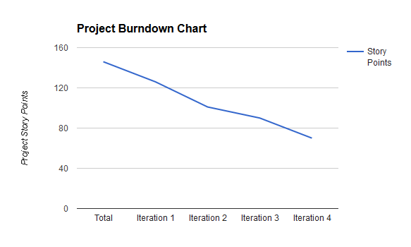

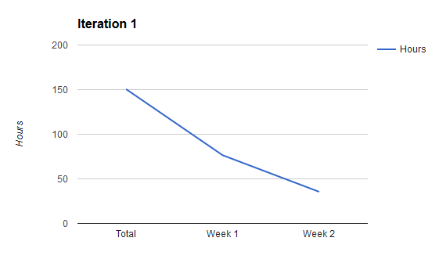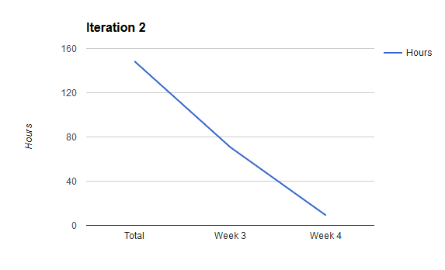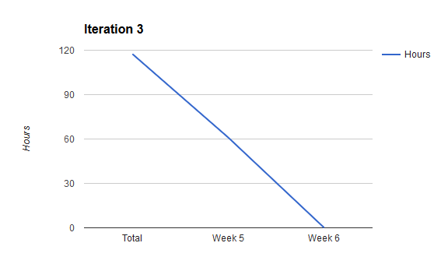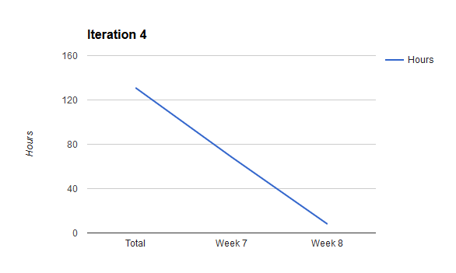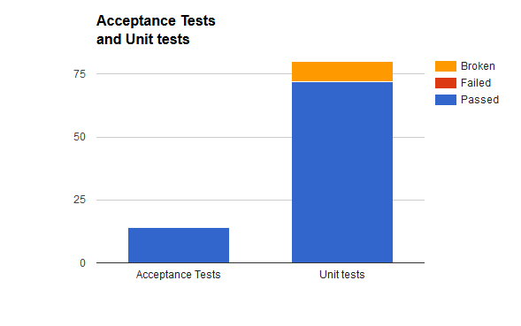

# Customer Engagement

Week 8 (Richard)

* Showed a demo of the first release.
* We negotiated about taking a week to improve our pipelines.

Week 9

* No customer engagement (customer sick)

Week 10 (Erica)

* Showed the customer how the toggle that turns off the geofence checks.
* Showed the customer the advanced notification system.
* Talked about the timer based fences system.
* Talked about the advanced geofences system. Decided to use  a tunnel based system for this part.
* Talked about the messaging system.
* Agreed to a partial completion of the messaging system by the end of the 2nd release. (based on how many story points we could complete during iteration 4.
* Agreed that the toggle button that disables the fence checks should not disable the panic button as well.

Week 11

* No customer engagement (customer sick)

Week 12 (Erica)

* Showed the client the messaging systems for both applications.
* Client asked us to improve the naming system of the application to allow people to use other people’s phones and still be recognisable.

Reflection

**Worked well?**

* There is communication among all the team members.
* At least three stands up meeting held in each week using both physical and online Skype meeting. (Tuesday, Thursday and Sunday)
* Using each member’s expertise to solve issues.
* Understand each other’s strength and weakness (skill level).
* Using facebook to solve confusions.
* Had no team conflict issue in the team during the whole process of the project.
* Add extra time on each Task that involves a new piece of technology, so that people can do some research.
* Using spikes to try unfamiliar technology, before implementing it into the project.
* Based on the each team member skill the task has been divided, which gave better result.
* Pair programming has been used when issues arose in a task (on Sundays).
* Code Reviews have been performed before code is merged into the develop build.
* Improved estimated task, which really get effective in the whole project.
* Using a N.E.A.T document every week, to update and track each other time and progress. Which helped to update the entire document like Velocity graph, Release/Iteration Burndown chart, Test graph, etc.

**What didn’t work well?**

* Although we have been trying to do some Test Driven Development, testing activities for android has proven to be very difficult for us.
* The difference in expertise did cause some issues.
* Miss-estimation of task was less but still a minor issue.
* Early on, had issues with the system we were using to track our progress.
* Code standards have not always been kept.
* Customer engagement was a bit lacking.

**Changes to be made**

* Use of pair programming throughout the week instead of only once a week.
* Refactoring some of the earlier activities to allow for a new method of testing activities
* Make code standards more explicit.
* Should have emailed the customer our progress.